Week 7 (Months, Days)

Exercise 1: Watch the videos and the slide.
https://www.youtube.com/watch?v=hgRv2th8WEk
https://www.youtube.com/watch?v=16J0rLrUPhI
https://slideplayer.gr/slide/3154240/

Exercise 2: Go to http://2nip-komot.rod.sch.gr/test_MINES.htm
Step 1:
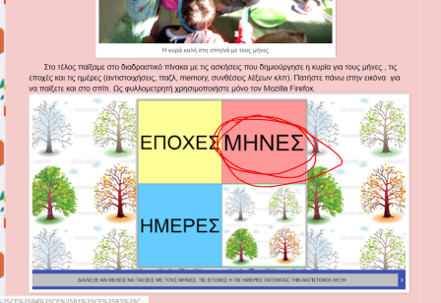
Step 2: Match the month to the picture.
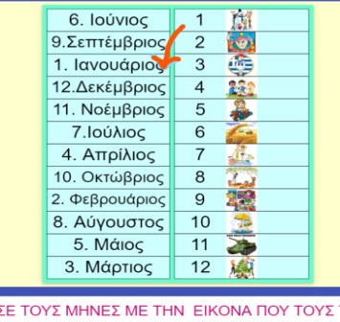

Exercise 3: Go to http://www.jele.gr/activity/b/language/glossaB016.swf
Step 1: Click on the right season.
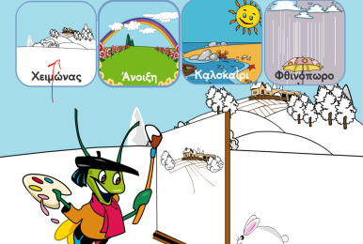
Step 2: Put the months in the right order.
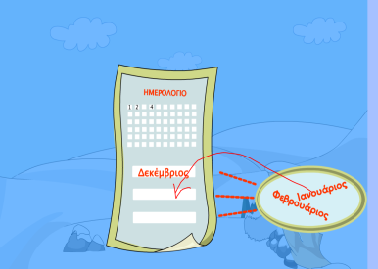

Exercise 4: Go to http://photodentro.edu.gr/aggregator/lo/photodentro-lor-8521-5057
Click on each month and see the fruit that are available at that time of the year.
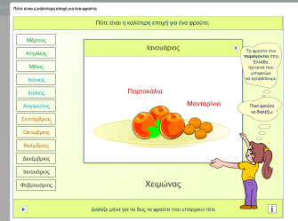

Exercise 5: Go to https://www.youtube.com/watch?v=XllRfDYPleA
Go to Google translate and find out what the words “χθες”, “σήμερα” and “αύριο” mean.

Exercise 6: Go to http://2nip-komot.rod.sch.gr/test_MINES.htm
Step 1:
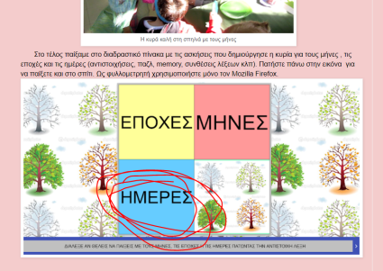
Step 2: Write down how many days a week has.
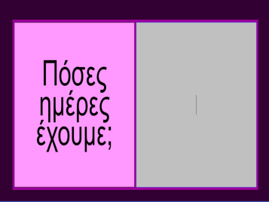
Step 3: Put the letters in the right order to form the days.
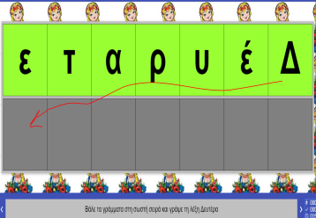

Exercise 7: Go to http://www.jele.gr/activity/b/language/glossaB014.swf
Step 1: Place the days in the right order.
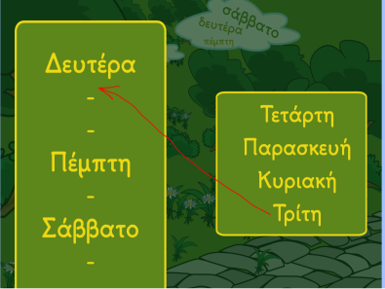
Step 2: Use the right symbol for each sentence.
We use . at the end of a sentence, but ; if the sentence is a question.
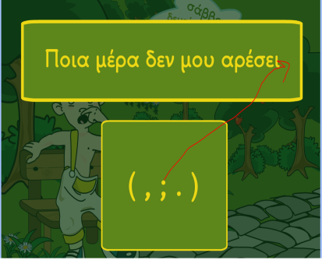

Exercise 8: Watch the video https://www.youtube.com/watch?v=BMONbjfPCxk
The lyrics are available on «Στρουμφ»

