Week 3 (The body)
Exercise 1: Watch the videos.
- https://www.youtube.com/watch?v=Iy24oFrHQj0
- https://www.youtube.com/watch?v=_Baa-xPS8SA
- https://www.youtube.com/watch?v=B6oQO0Y2AGc
Exercise 2: Go to http://polydromo.web.auth.gr/index.php/el-gr/yliko/playing-with-languages Click on the words and see the body parts.
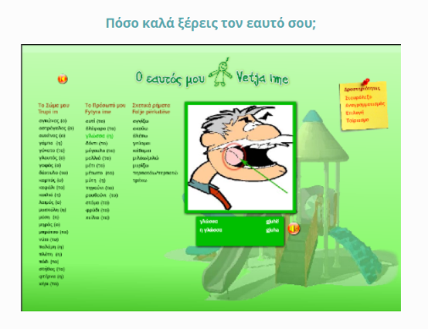
Exercise 3: Go to http://www.mikrapaidia.gr/ccs9/
Step 1:
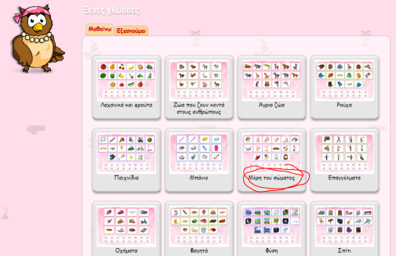
Step 2:
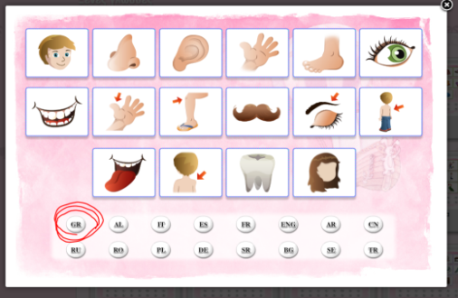

Exercise 4: Go to "Σώμα 1". Read the words.
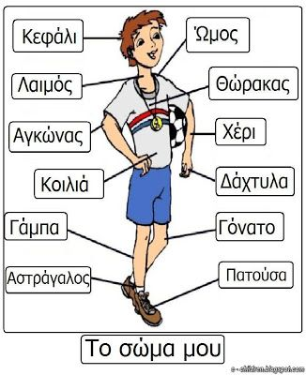
Go to "Σώμα 2" and write as many words as you can.
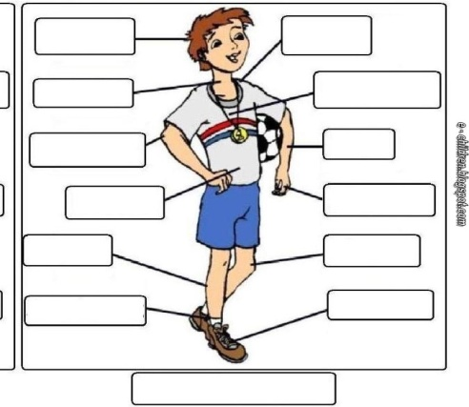

Exercise 5: Go to "Αισθήσεις". Tick in the right box.
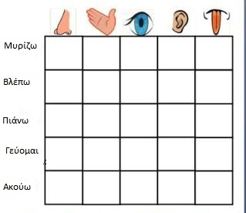

Exercise 6: Draw a friend of yours and write down as many body parts as you can remember.

Exercise 7: Go to http://photodentro.edu.gr/lor/r/8521/10767
Step 1:
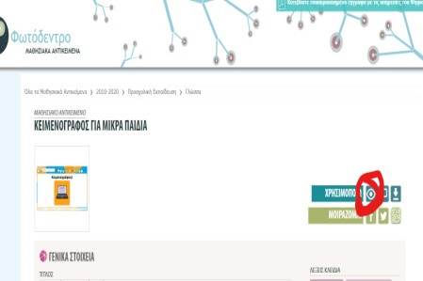
Step 2:
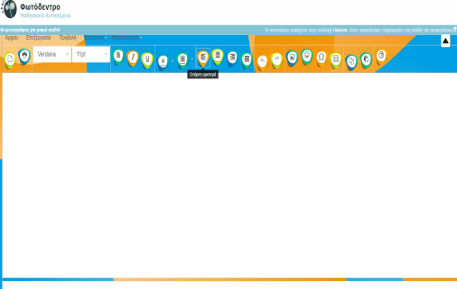
Write these words
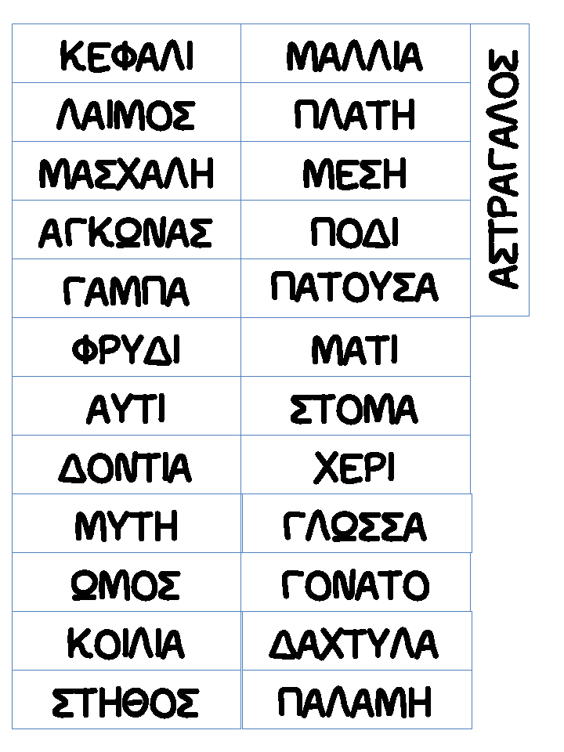

Exercise 8: Go to "Αντιστοίχιση". Match the image to the word.
